Press Release 2018
- European Year of Cultural Heritage – 10th February 2018
- Casina dell'Aquila – Notice 29 January 2018
- Notice: Cryptoporticus & Fullonica - 7 February 2018
- Gen. Cipolletta new director GPP – March 19, 2018
- Pompeii, new excavations Regio V – march 23 2018
- Discovery Pompeii Civita Giuliana - May 7, 2018

10th February 2018
Archaeological park of Pompeii (10:30)
Temporary Museum of Enterprise of the City of Pompeii (14:30)
‘‘EUROPEAN YEAR OF CULTURAL HERITAGE 2018’’
Pompeii for All. Accessibility of Archaeological Sites
2018 has been recognised as ‘European Year of Cultural Heritage’. A year dedicated through various national initiatives, to the celebration, yet also reflections and debates, on the value that cultural heritage holds for our society and in the different sectors of public and private life.
On the 10th February, the Archaeological Park of Pompeii and City of Pompeii will celebrate the ‘European Year of Cultural Heritage 2018. Pompeii for All. Accessibility of Archaeological Sites’, focusing on the theme of accessibility to our cultural heritage, a condition of fundamental importance which is nonetheless not yet taken for granted.
The event, organised by the Ministry of Cultural Heritage, Activities and Tourism, along with the Archaeological Park of Pompeii and the City of Pompeii, seeks to address the issue of accessibility for people with motor, sensory and cognitive disabilities, as well as inclusion, in order to guarantee the opportunity and right to be citizens in all respects to all persons, without distinction. The actions taken toward overcoming tangible, intangible and digital barriers in many museums, as well as guidelines, good practices and prospects for the future, will also be analysed.
At 10:30 at the Archaeological Park of Pompeii, the extension to the ‘Pompeii for All’ itinerary will be presented, which is an itinerary designed to facilitate visits for people with mobility difficulties, including a visit to the House of the Geometric Mosaics with the Courtyard of the Moray Eels, and the new experimental system of WITH-Me bracelets, for an accessible, inclusive and safe visit. The bracelet worn by the disabled visitor, is able to send signals through electronic identity to a central server that then processes them and carries out actions aimed at safeguarding visitors. The itinerary ‘Pompeii for All’, carried out under the Great Pompeii Project and co-funded by the European Union, has already distinguished itself as a model of accessibility, allowing anyone - without exclusions and barriers - to be able to benefit from common archaeological heritage, experimenting with new technological supports.
The Paralympic Defence Sports Group (GSPD) and the Guardia di Finanza Fiamme Gialle Paralympic Sports Group will attend the event.
At 14:30, at the Temporary Museum of Enterprise of the City of Pompeii, in Piazza Bartolo Longo, a European conference will speak on the state of accessibility to cultural heritage in Italy and Europe.
For information and accreditations: pompei.ufficiostampa@beniculturali.it

Casina dell'Aquila - Notice
For restoration site of Casina dell'Aquila, the toilette behind the building will remain closed to the public from Monday, January 29th to Friday, February 2nd, 2018.

Notice: Cryptoporticus & Fullonica
In order to allow restoration work in the Casa del Larario of Achille, the House of the Cryptoporticus and Fullonica of Stephanus will remain closed until further notice.
Gen. Cipolletta new director GPP
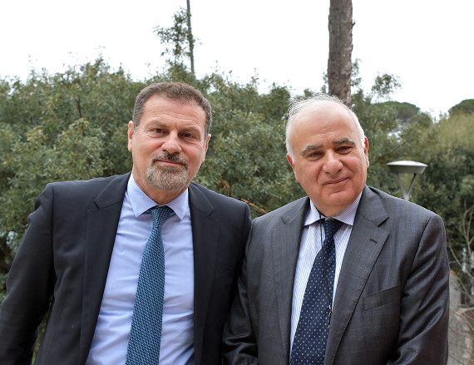
Change of the top of the Great Pompei Project, which sees the General of the Carabinieri Mauro Cipolletta take over from General Luigi Curatoli, at the end of his term after two years at the head of the General Management. General Cipolletta was appointed by Decree of the President of the Ministerial Council of 27 February 2018, until 31 December 2019.
Pompei, March 19, 2018

POMPEII. NEW EXCAVATIONS IN REGIO V.
AFTER DECADES, A NEW AREA OF POMPEII IS EXCAVATED
270 years after the discovery of Pompeii, the Archaeological Park celebrates its wonders by announcing new ongoing excavations in Regio V
On the 23rd March 1748, ten years after the discovery of Herculaneum, a fortunate discovery of certain finds in the vicinity of Civita, refocused the attention of the Bourbon excavations to this area. Initially believed to be the city of Stabiae, only in 1763 were the ruins discovered to instead be those of the ancient city of Pompeii.
270 years later, the anniversary of this great beginning, which changed the course of archaeological history and gave the unique heritage of Pompeii to the world, is celebrated through the announcement of new excavations, which recently began in a section of Regio V. This is an important excavation in an area which has not been investigated since the postwar period.
Thursday, March 22 at 11:30 the site area, with the first structures emerged and the findings found, were illustrated by the General Manager, Massimo Osanna and the Director General of the Great Pompeii project, Mauro Cipolletta.
- Live Facebook
- Download Press Kit

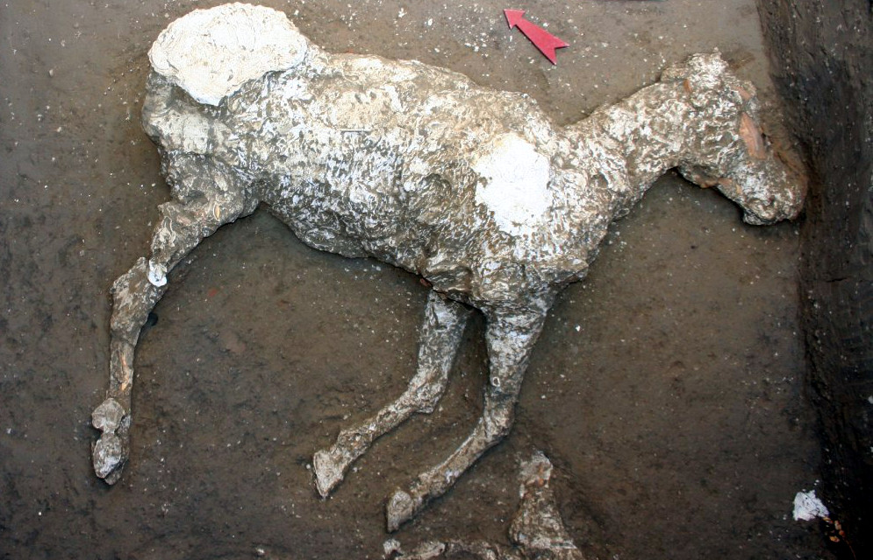
Pompeii Civita Giuliana
EXTRAORDINARY DISCOVERY among the TUNNELS of ILLEGAL EXCAVATIONS
JOINT OPERATION BETWEEN PUBLIC PROSECUTOR’S OFFICE, CARABINIERI AND THE ARCHAEOLOGICAL PARK OF POMPEII to save endangered archaeological heritage
Extraordinary discovery in the area of Civita Giuliana, to the north of the walls of the Archaeological Site of Pompeii, where illegal tunnels were intercepted.
Thanks to the joint operation of the Archaeological Park of Pompeii with the Public Prosecutor’s Office of Torre Annunziata, investigators of the Carabinieri Command Group of Torre Annunziata and the Cultural Heritage Protection Unit of Naples, who had already been investigating these illegal activities, since last August an excavation operation has been underway in order to advance the investigation and save the endangered archaeological heritage.
The Director General of the Archaeological Park of Pompeii, Massimo Osanna exclusively present the exceptional recovery, as well as the operation carried out with the ongoing excavation work.
The intervention has brought to light a series of service rooms from a large, exceptionally well-preserved suburban villa, from which a variety of finds have emerged (amphorae, kitchen utensils and part of a wooden bed whose cast it has been possible to make) and a tomb dating to the post AD 79 period, which guarded the skeleton of the deceased.
For the first time it has been possible, through casting technique, to reconstruct the complete outline of a horse, found in one of the excavation rooms.
- The excavations of civita giuliana
- Intact cast of a horse
- The tomb of Civita Giuliana
- Video Press Conference
- Video Discovery Civita Giuliana

